Q.5 Generate a model for Covid 19 with symptoms of parameters like fever, cold, shivering,weight loss, generate 100 model data with random values for each parameter and order by parameter lowest to highest in display based on the input parameter.

**Project 2: Covid-19 Symptoms Tracker and Analyzer**

**Introduction:**

This code simulates the generation of COVID-19 patient data and provides functionality to sort this data based on specific symptoms. It consists of a class definition for patient data modeling, a function for data generation, and a function for sorting based on symptom severity.

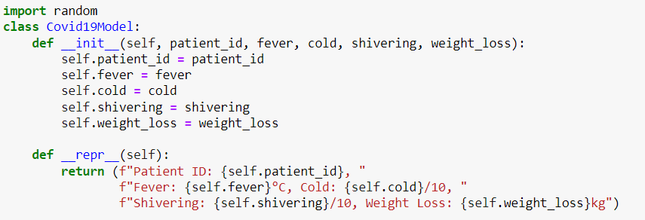

**Covid19Model Class**: This class models a COVID-19 patient.

* **__init__ Method**: Initializes a patient with attributes like patient_id, fever, cold, shivering, and weight_loss.
* **__repr__ Method**: Provides a formatted string representation of the patient, which helps in easily reading and debugging the patient data.

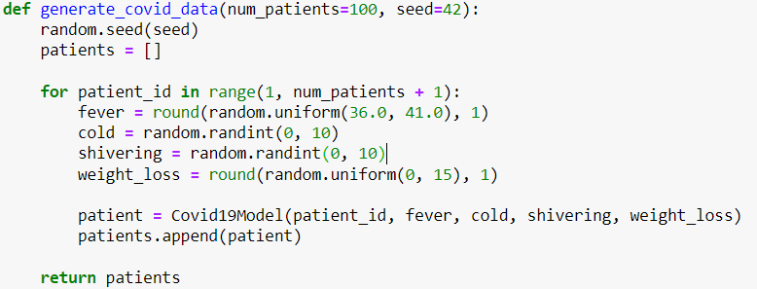

This functioncreates a list of Covid19Model instances with random symptom data.

Number of patients to generate (default is 100).Seed for the random number generator to ensure reproducibility (default is 42).

Sets the random seed.Creates an empty list patients.Loops to create num_patients patients with random values for fever, cold, shivering, and weight_loss.Appends each Covid19Model instance to the patients list.

Returns the list of generated patients.

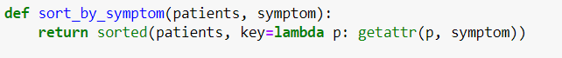

The sort_by_symptom function sorts a list of Covid19Model instances based on a specified symptom attribute (e.g., 'fever'). It uses the sorted function with a lambda function to extract and sort by the chosen attribute, returning the sorted list.

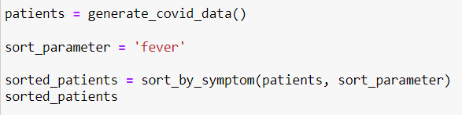

generate_covid_data() creates a list of 100 patients with random symptoms. sort_by_symptom(patients, 'fever') sorts this list by fever temperature, with sorted_patients containing the sorted data.

**Output:** The sorted_patients list will show patients arranged in ascending order of their fever temperature, making it easy to analyze which patients have higher or lower fevers. Each patient entry includes their patient_id, fever temperature, cold severity, shivering intensity, and weight loss, formatted for readability.

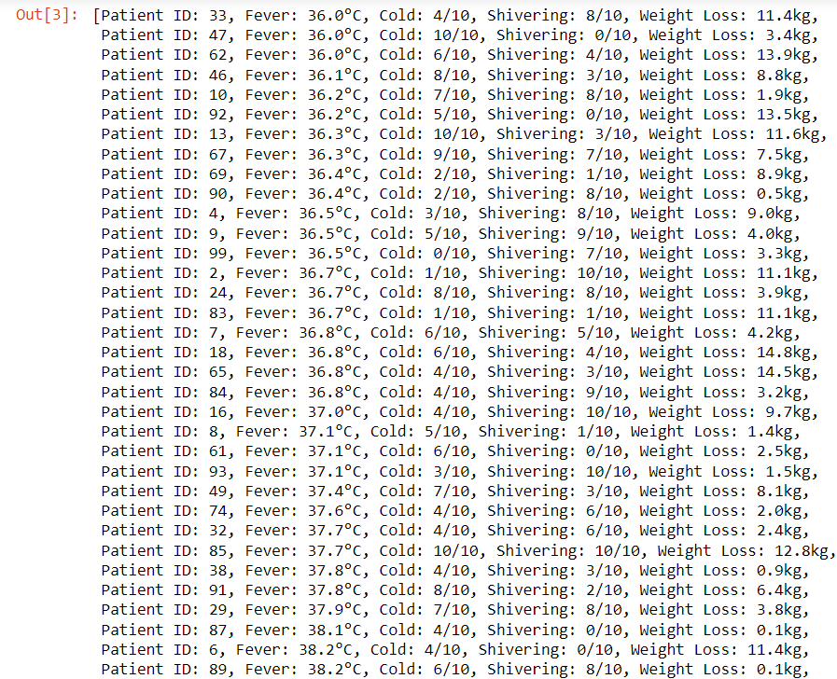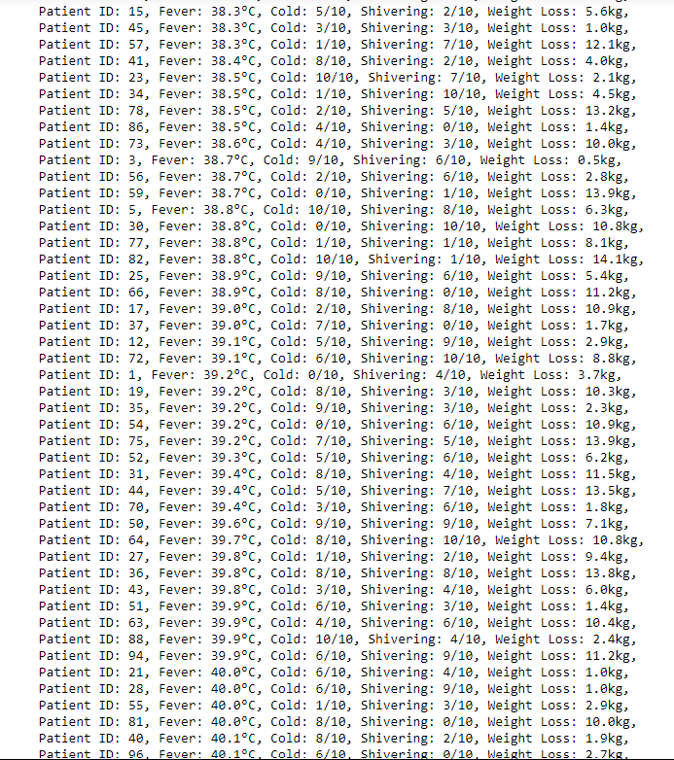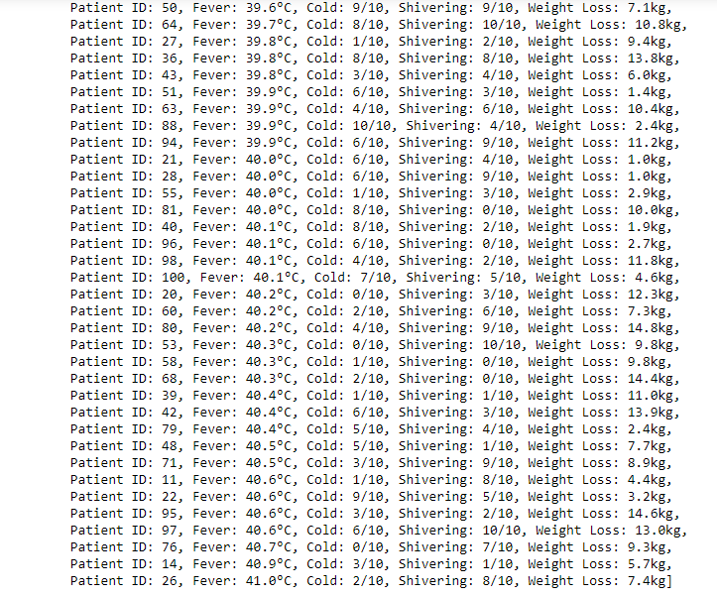

The code provided simulates and organizes COVID-19 patient data. It uses the Covid19Model class to create patient records with attributes like fever, cold severity, shivering, and weight loss. The generate_covid_data() function generates a list of 100 patients with random symptom values, while the sort_by_symptom() function sorts this list based on a specified attribute, such as fever. The result is a sorted list of patients, which helps in analyzing and comparing the severity of symptoms across different patients.